**LAB 3 :**

DATE : 2/ 10 /23

ROLL NO: 213064

Name : Khansa

Subject: VP

CODE SNIPPET 1:

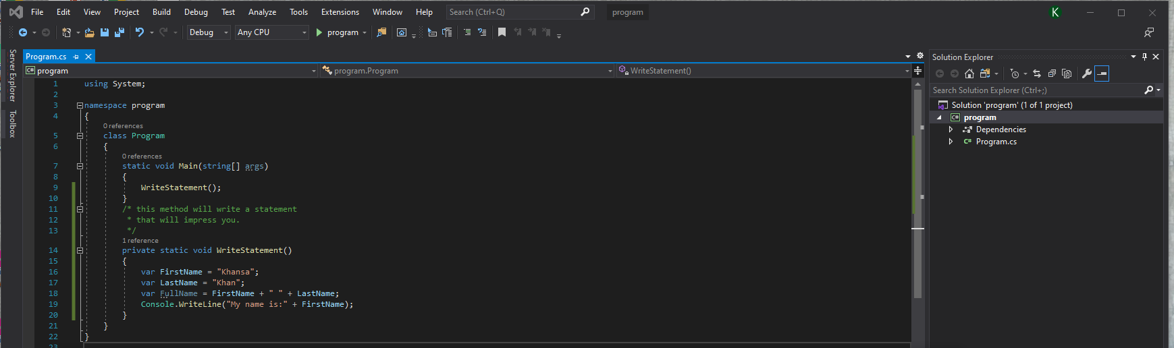

OUTPUT:

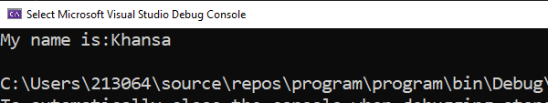

CODE SNIPPIT 2:

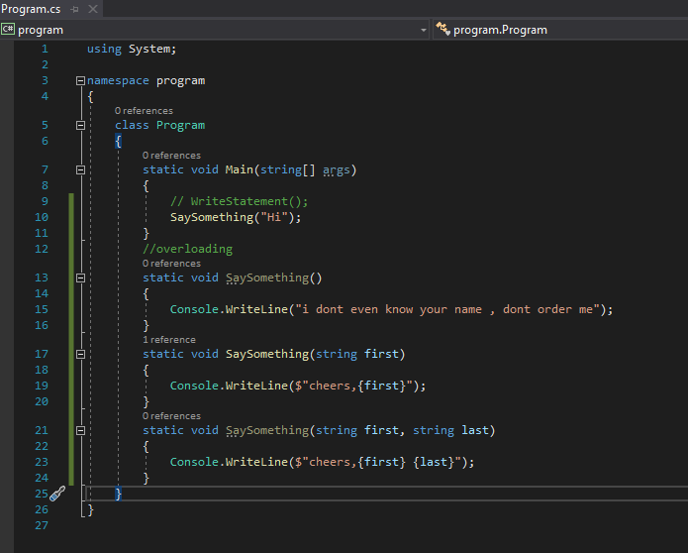

Output: 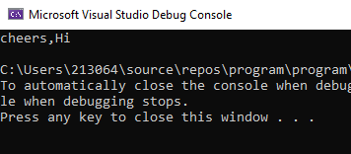

CODE SNIPPET 3:

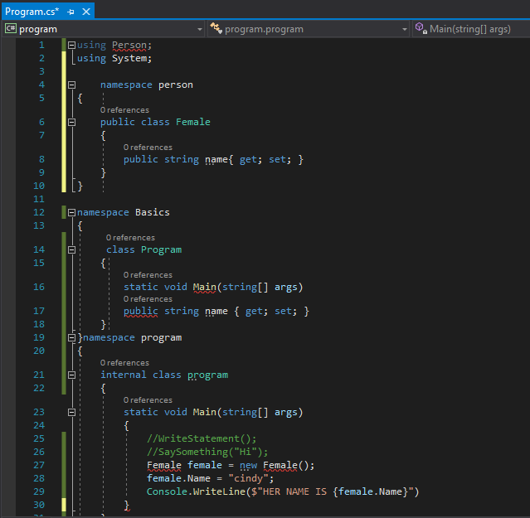

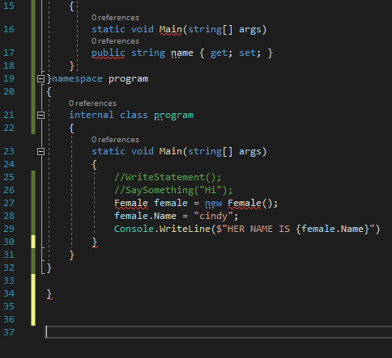

CODE SNIPPET 4:

namespace Project4

{

internal class Program

{

static void Main(string[] args)

{

DisplayOutput();

}

private static void DisplayOutput()

{

var population = 66000000;

var weight = 1.88;

var price = 4.99M;

var fruits = "Apples";

Console.WriteLine($"The Uk population is

CODE SNIPPET 5:

using System;

namespace Basic

{

class Program

{

static void Main(string[] args)

{

GetInput();

}

private static void GetInput()

{

Console.Write("Type your name and press Enter:");

string firstName = Console.ReadLine();

Console.WriteLine("Type the page number you are on and press Enter: ");

string pg = Console.ReadLine();

Console.WriteLine($"Hello{firstName},your page nunmber is{pg}");

Console.WriteLine($"The Uk population is

{population: No}");

Console.WriteLine($"{weight} kg of {fruits}

cost {price:C}");

}

}

}